

**Deed Governance Group**

**Policy**

**Engagement across the biosecurity system under GIA**

**Document control**

Version: 10 January 2017  
Status: Endorsed by GIA DGG (October 2016)  
Review: One-year from date of adoption  
Permissions: General Release

**Disclaimer**

The information in this document is intended to be general information. It is not intended to take the place of, or to represent, the written law of New Zealand or other official guidelines or requirements. While every effort has been made to ensure the information in this document is accurate, the Deed Governance Group (comprised of MPI and industry GIA partner representatives), including any of their employees or agents involved in the drafting of this Guide, does not accept any responsibility or liability for any error of fact, omission, interpretation or opinion which may be present, nor for the consequences of any decisions or actions based on this information.

Contents

Introduction 4

Audience and intended use 4

Review 4

Enquiries 5

Biosecurity in New Zealand: An overview 6

Engagement across the biosecurity system under GIA 8

Appendices 11

A1 - New Zealand’s biosecurity system 11

A2 - Key responsibilities for biosecurity in MPI 12

A3 - GIA Engagement spectrum 13

A4 - Outcomes and Principles for Engagement under GIA 14

A5 - GIA partner biosecurity system activities and engagement opportunities 15

A6 - Template for sector specific biosecurity system activities and engagement 27

A7 - Key biosecurity fora of relevance for GIA 31

## Introduction

The Government Industry Agreement for Biosecurity Readiness and Response (GIA) is a Partnership between government and industry for improving New Zealand’s biosecurity.

The GIA Deed (the Deed) establishes the basis for the Partnership and came into effect in May 2014.

The scope of the Deed covers engagement across the end-to-end biosecurity system.

This document sets out what GIA Partners (MPI and industry) mean by and expect from each other with respect to engagement. It includes biosecurity system context and other material that may help GIA Partners with associated interactions. While collated here into a single document, each section has been uploaded onto the GIA website as a separate document for quick reference.

The way and extent to which GIA Partners engage with each other will continue to evolve as the GIA Partnership matures. This document can be updated to reflect any developments.

## Audience and intended use

**Primary audience**

GIA Partners – to create a foundation for more informed interaction and discussion about the biosecurity system, including ways in which it might be improved. For example, through meetings of the GIA Deed Governance Group (DGG), bi-lateral discussion between MPI and each industry Partner, GIA Sector Based Councils (eg, Fruit Fly Council, Livestock Council), Operational Agreement negotiations, and ad hoc issues management.

GIA potential Signatories – to provide information on the benefits of becoming a GIA Partner from an ‘engagement across the system’ perspective. This information will help primary industry organisations with the development of a business case for signing up to the Deed.

**Secondary audience**

Stakeholders that cannot or are unlikely to join GIA – to provide information on the biosecurity system, engagement opportunities and methods that may be of equal interest and relevance to non-GIA Signatories

## Review

This Policy is owned by the GIA Secretariat. It was drafted with input from MPI and industry representatives and senior leaders, and endorsed for release by the GIA DGG. The Policy will be reviewed as required to ensure it continues to represent the single source of truth for GIA partner engagement across the end-to-end biosecurity system. The DGG are responsible for determining the need and process for review.

## Enquiries

For any enquiries about this Policy, contact the GIA Secretariat.

**Email** [secretariat@gia.org.nz](mailto:secretariat@gia.org.nz)  
**Phone** 04 894 0419  
**Post** 25 The Terrace, PO Box 2526, Wellington

## Biosecurity in New Zealand: An overview

**Biosecurity is the exclusion, eradication or management of pests and diseases that pose a risk to the economy, environment, cultural and social values, including human health – Biosecurity 2025 Direction Statement**

Biosecurity is critical to protect our taonga (treasures), our economic prosperity, our way of life and our national identity.

The biosecurity system protects:

* New Zealand’s unique biodiversity and natural environment;
* The parts of the New Zealand economy that depend on natural resources; and
* The health, social and cultural well-being of all New Zealanders.

New Zealand has a premium biosecurity status which provides an export trade advantage. We are able to assure our trading partners that our goods are free from pests and diseases[1], which allows access to overseas markets and attracts a premium for our products. Our producers also have a competitive advantage as they don’t have to battle many of the same pests and diseases as their international competitors.

Biosecurity measures have been in place in New Zealand for centuries as an integral part of Māori cultural practices through tikanga and kaitiakitanga. National laws to protect New Zealand from harmful pests and diseases can be traced back to the mid-19th century.

The term biosecurity gained prominence in the early 1990’s when the [Biosecurity Act 1993](http://www.legislation.govt.nz/act/public/1993/0095/latest/DLM314623.html) brought together the broad programme of activities that we now think of as biosecurity. From 2003, New Zealand’s biosecurity system was guided by the first *Biosecurity Strategy; Tiakina Aoteraroa – Protect New Zealand* (the 2003 Biosecurity Strategy).

The biosecurity system works offshore, at the border and within New Zealand to keep pests and diseases out of the country and to eradicate or effectively manage those do get in and establish here (Figure One). The diagram in Appendix One shows how MPI represents the different layers that make up New Zealand’s biosecurity system.

**Strengthening the system**

The 2003 Biosecurity Strategy provided guidance for improvements across the system. However, [threats and pressures](https://www.mpi.govt.nz/document-vault/9488) have continued to grow, for example, because of growing international trade, greater mobility of people and increasingly complex global supply chains.

In November 2016 the Minister for Primary Industries launched the [*Biosecurity 2025 Direction Statement for New Zealand’s biosecurity system*](http://www.mpi.govt.nz/protection-and-response/biosecurity/biosecurity-2025/)(Biosecurity 2025). Biosecurity 2025 updates and replaces the 2003 Biosecurity Strategy, and sets the direction for the biosecurity system through until 2025. It was drafted with broad input from stakeholders, iwi and the New Zealand public. Implementation will also be a system-wide collaborative effort requiring wide involvement from central and regional government, iwi, GIA partners, industry and other biosecurity system participants.

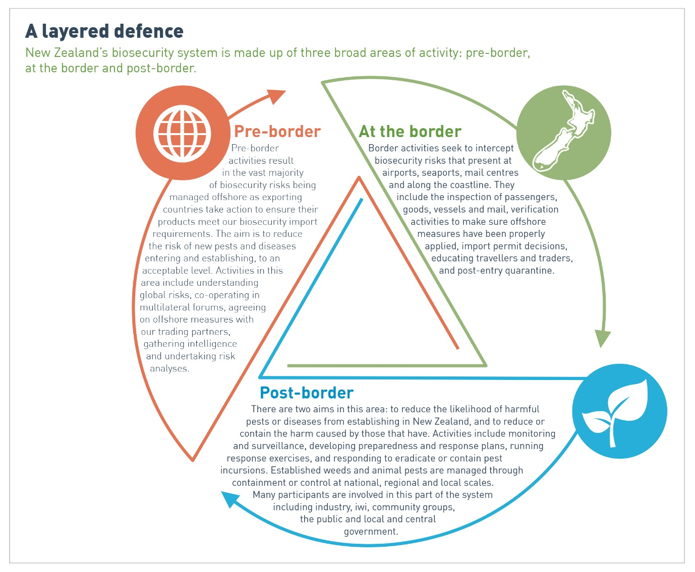

**Figure One – A layered defence**

**Biosecurity system roles and responsibilities**

The Ministry for Primary Industries (MPI) is accountable for overall management of the biosecurity system on behalf of all New Zealanders. MPI is also responsible for the delivery of many of the activities in the biosecurity system, either directly or through its contractors, and provides policy advice on biosecurity issues to the Minister for Primary Industries.

The diagram in Appendix Two depicts MPI’s organisational structure highlighting where key responsibilities lie for delivery of biosecurity system activities. For a high level overview of MPI’s different work areas and the key contacts within them, refer to *MPI’s Work Areas and Key Contacts* publication available both in hardcopy and electronically (under development – link to be added).

Many others also play a critical role in the biosecurity system, including central and local government, Maori/iwi, primary industry organisations, and community groups.

The GIA Partnership presents the opportunity to unlock more substantial contributions and improve biosecurity outcomes. For example, through offering:

* Strengthened relationships among system participants
* Access to effective points of influence for the management of biosecurity risk
* Joint decision-making for readiness and response activities.
* A broader range of expertise and knowledge; more resources and capability
* Improved networks for communication and engagement.

## Engagement across the biosecurity system under GIA

**What does engagement mean?**

“Engagement” under GIA refers to the processes through which MPI and GIA industry Partners build a relationship, and gain mutual understanding of our work together in biosecurity risk management activities.

The notion of engagement encompasses a spectrum of shared activity, ranging from one party telling the other party what it has done, to both parties sharing decision-making or even handing decision-making responsibility over to others. A spectrum is an appropriate way to consider how engagement is undertaken across the biosecurity system because the degree of joint activity will vary significantly depending on the circumstances.

GIA uses an engagement spectrum based on *MPI’s Building Strategic Relationships Toolkit* (2012) which describes five levels of engagement - Informing, Networking, Cooperation, Collaboration and Partnership. Appendix Three gives examples of defining factors and techniques that would expected for each.

**Expectations for engagement**

Engagement improves outcomes and enables better planned and more informed policies, projects, programmes and services. However, the process of engagement itself is also valuable. In addition to enhancing results of the matter being engaged on – through pooling expertise, resources and experience – it has the additional benefit of building more trusting relationships. The mutual respect and understanding generated create an excellent foundation for working together on a much wider range of activities. These relationships reduce the transaction costs of working together and can help more timely and effective development of risk management solutions.

Appendix Four sets out what GIA Partners expect to achieve through engagement (Outcomes) and for behaviours during engagement (Principles).

Key questions to keep front of mind for all engagement activities, include:

1. Is the engagement meaningful?
2. Are we building on each other’s strengths?
3. Where are the areas that could benefit most from enhanced engagement?

Appendix Five provides guidance on the level of engagement GIA Partners can expect from each other for specific activities undertaken across the biosecurity system.

Appendix Six translates the key information from the engagement table in Appendix Five into a template that can be used by MPI and industry Partners to identify specific biosecurity system activities of relevance to each sector, map their experience of engagement against what is expected, and to support discussions on both.

The GIA Deed identifies specific engagement fora for GIA Partners – annual bi-lateral meetings between MPI and each industry partner, and bi-annual Biosecurity fora open to all GIA Partners to collectively discuss biosecurity matters. Table One in Appendix Seven provides information on these (and other) GIA specific fora. Table Two lists other key fora which have wider membership than GIA Partners, but that provide important opportunities for MPI and industry to identify, discuss and work together on biosecurity system activities of mutual interest.

For some activities (particularly in the pre-border parts of the biosecurity system) and to meet its obligations as a competent authority (refer below), MPI is unable to provide the full spectrum of engagement opportunities. However, GIA Partners can still influence risk-management activities in these parts of the system through proactive engagement in statutory processes. Where appropriate, MPI will also work groups such as the GIA DGG and Sector-based Councils to seek and receive coordinated and collective feedback from interested Partners.

Maximising engagement opportunities available to all stakeholders along with those specific to industry Partners, will help to increase understanding, involvement and influence across the end-to-end biosecurity system. It will also significantly increase interaction between industry and staff across MPI, offering the potential to cement relationships, and grow trust and confidence.

**MPI’s role as competent authority, and what this means for engagement**

MPI is New Zealand’s competent authority[2] responsible for performing regulatory, market access and trade policy functions, and must be able to demonstrate that it has made its decisions within international trading rules that apply*.*

New Zealand has a significant comparative advantage over competitors as a result of:

* Our reputation for taking a strategic and principled approach to our engagement in international standard-setting bodies and bilateral trade relationships, and
* Consistent adherence to the international rules when making decisions under our food, biosecurity and trade systems.

This reputation has been built through the quality of our engagement in international settings and a significant level of investment over many decades. New Zealand’s ranking as one of the most transparent, corruption-free countries in the world also feeds into the integrity of what we say, do and sell.

A relatively small player in the international arena, New Zealand relies heavily on its reputation to leverage market advantage against much bigger nations that hold significant influence on that basis.

Decisions and actions taken by MPI (as competent authority) which affect international trade are closely scrutinised by MPI’s international counterparts. The competent authority must be consistent, impartial, and free of improper or undue influence or conflict of interest. Any action that could create the perception of a conflict of interest could damage New Zealand’s reputation. For example, if government decisions were seen to be overly influenced by stakeholders with actual or perceived gains to be made from restricting imports to stop pests and diseases and/or to reduce competition.

For this reason, engagement under GIA, including industry Partners’ role in biosecurity system governance needs to be clearly defined, understood and communicated to avoid any unintended market access consequences or damage to NZ’s international reputation.

When consulting on international standards and systems or under statutory obligations, MPI is obliged to consult in an inclusive, fair and transparent manner, and to treat all stakeholders equitably. Within these boundaries MPI recognises GIA Partners as a key group representing the interests of potentially affected parties and on this basis will always consult with GIA Partners on matters where they have an interest.

**Biosecurity Act 1993**The Biosecurity Act 1993 provides the legal framework for MPI and others to help keep harmful organisms out of New Zealand and respond if any do make it into the country.

Part 3 of the Act deals with the importation of goods, with sections 20-24 dealing specifically with Import Health Standards (IHSs). The Act requires MPI to develop IHSs in a manner that respects New Zealand’s obligations under the Sanitary Phytosanitary (SPS) Agreement, in particular the principles of least trade restrictive and avoiding arbitrary discrimination. MPI believes that avoiding arbitrary discrimination applies equally to the processes used to consult and engage with international and domestic stakeholders.

## Appendices

### A1 - New Zealand’s biosecurity system[3]

The biosecurity system involves government, industry, Maori and all New Zealanders working together to manage risks posed by pests and diseases to the economy, environment and human health.

The biosecurity system is based on risk management activities undertaken across a range of inter-related areas – pre-border, at the border and post-border. Some of the activities and outcomes in each layer are described below.

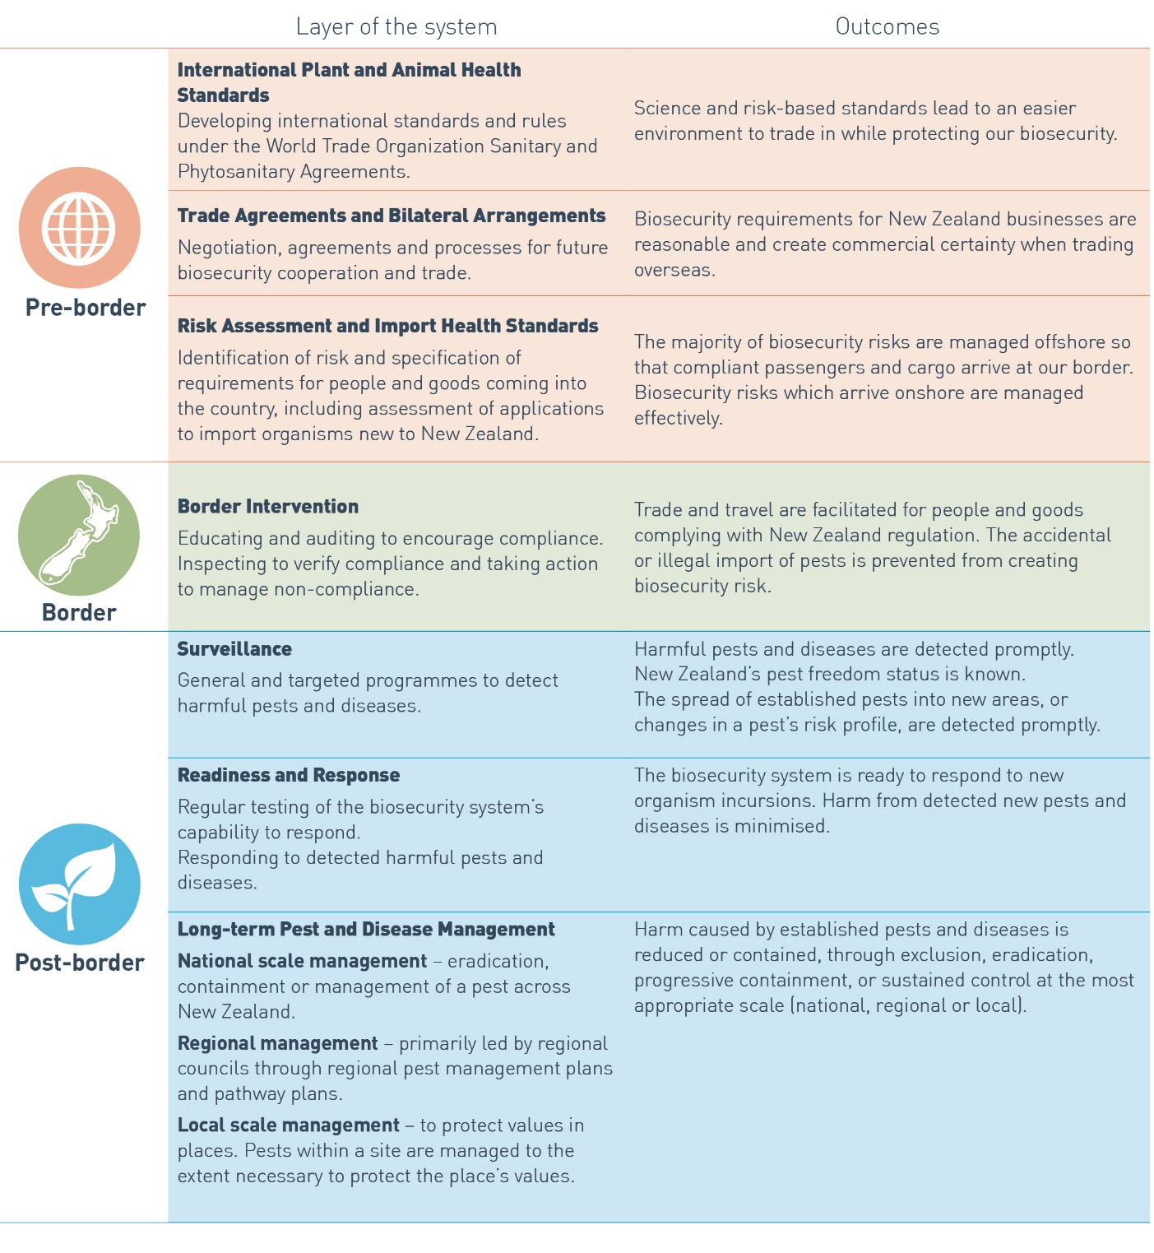

### A2 - Key responsibilities for biosecurity in MPI

*The following diagram shows the six Branches that make up the MP organisational structure, highlighting each Directorate where the key responsibilities for each biosecurity layer lie. For more information about MP’s organisational structure, refer to the MPI website* [*here*](http://mpi.govt.nz/about-mpi/governance-and-structure/)



### A3 - GIA Engagement spectrum

The following diagram sets out the categories used by GIA Partners to describe engagement (based on those defined in the *MPI Building Strategic Relationships Toolkit (2012).* It includes defining factors and examples of engagement techniques for each.

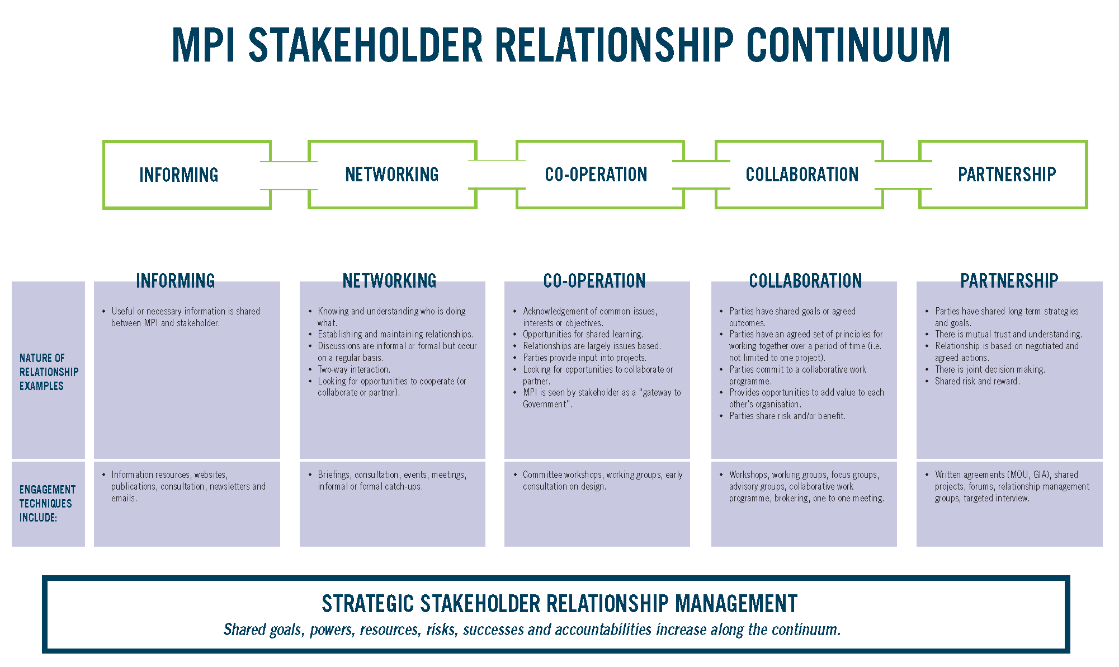

### A4 - Outcomes and Principles for Engagement under GIA

The following Outcomes and Principles set out what GIA Partners expect to achieve through engagement (Outcomes) and behaviours during engagement (Principles).

Key questions to keep front of mind for all engagement activities, include:

1. Is the engagement meaningful?
2. Are we building on each other’s strengths?
3. Where are the areas that could benefit most from enhanced engagement?

**Outcomes**

The ultimate purpose of engagement is to achieve better biosecurity outcomes and biosecurity system improvement.

Specific outcomes the Partners expect to achieve are:

1. Shared understanding:
   * of the system and its performance
   * of each other – including the contexts within which we work, our respective constituencies and obligations, the strengths and capabilities that we bring to the system, the range of activities we undertake
2. Confidence in the system and what it is delivering
3. Strong relationships with good communication and high levels of trust
4. Greater responsiveness and agility in the way we work together and deal with new risks and opportunities as they emerge.
5. Greater opportunities to realise benefits from innovation and new technologies
6. Enhanced collective capability and capacity, greater resilience
7. More effective and efficient deployment of resources, knowledge and expertise
8. Greater ability to draw on and influence the contributions of others. For example, non-GIA stakeholders
9. Improved economic basis for future initiatives. For example, through collective advocacy for funding, or co-investment.

**Principles**

1. **Outcomes focused** – Engagement is focused on achieving the outcomes above.
2. **Efficient and effective -** Engagement activities are planned, fit for purpose, and implemented in the most efficient and effective manner possible.
3. **The right people participate** – The parties bring sufficient knowledge and understanding to engagement, and are empowered to contribute.
4. **Respect** – Engagement will reflect respect for each party’s wider responsibilities and obligations. For example, industry’s need to represent constituents’ interests; the Crown’s obligations under the Treaty of Waitangi, and the international trading context within which decisions are made about biosecurity risk management.
5. **Pro-active** – The parties will seek out and facilitate the involvement of those potentially interested in or affected by their activities; engagement will be initiated as early in the process as possible, and will reflect a ‘no-surprises’ approach to keeping others informed.
6. **Open and transparent** – Parties will make information available to each other to enable participation in a meaningful way and will foster a culture of sharing ideas. The results of consultation and collaboration, and justification for decision making, will be communicated transparently.
7. **Confidentiality and clarity of process** - The roles and responsibilities of parties to engage over any particular matter, and the rules for cooperation, will be clearly defined; this includes mutual agreement and clarity around matters of confidentiality and privacy

### A5 - GIA partner biosecurity system activities and engagement opportunities

The following tables aim to provide guidance for GIA Partners (MPI and industry) on the level of engagement they should expect from each on activities across the biosecurity system.

Table One presents a high level summary for each layer of the biosecurity system.

Table Two is more specific about activities that are undertaken within each layer, and associated levels of engagement[4].

Note that these tables:

* use the Biosecurity System Layers as presented in Appendix One of this document
* use the engagement spectrum adopted by GIA Partners – refer Appendix Three of this document
* were developed by MPI under the guidance of MPI and industry representatives and senior leaders[5]
* can form the basis of an engagement heat-map for assessing expected versus actual engagement experiences
* in combination with biosecurity system performance metrics, should help set the foundation for more meaningful conversations about the biosecurity system, and opportunities for improvement
* can be updated as the GIA Partnership matures to reflect any changes to the way and extent to which GIA Partners engage with each other

**Table One - High level summary of the level of engagement GIA Partners should expect from each other for each layer of the biosecurity system**

For a more detailed breakdown of activities within each layer, and associated levels of engagement for each, refer Table Two.

| **Biosecurity system layer** | **Inform** | **Network** | **Co-operate** | **Collaborate** | **Partner** |  |  | |  | **COMMENTS** |
| --- | --- | --- | --- | --- | --- | --- | --- | --- | --- | --- |
| **ENGAGEMENT COLOUR KEY** | |
|  |  | Engagement with stakeholders |  |
|  |  | Engagement with GIA Partners |  |
|  |  |  |  |
| **Cross biosecurity system** |  |  |  |  |  | MPI is accountable for overall management of the biosecurity system on behalf of all New Zealanders. While activity dependent, MPI will cooperate wherever it can with stakeholders. MPI and GIA industry partners can identify opportunities to collaborate where an activity represents a joint priority and parties are seeking similar outcomes. Partnership (through joint decision-making) can happen in Surveillance, Readiness & Response, and Pest & Disease Management. Implementation of the final Biosecurity 2025 Direction Statement will likely include a review of system governance to improve transparency, inclusiveness and collaboration opportunities. | | | | |
| **International Plant & Animal Health Standards**  Developing international standards and rules under the WTO SPS Agreement |  |  |  |  |  | MPI represents New Zealand on international standard setting bodies where measures are developed to protect human, plant and animal health. These measures once agreed, apply to all member trading nations. New Zealand is a relatively small player in the international arena and MPI is an influencer not a decision-maker in these fora. Where possible[6], MPI will seek to cooperate with stakeholders. For example, through consulting on recommended priorities for work plans, and on the content of draft standards. MPI must be fair, transparent and equitable in the way it engages on these activities, and must therefore provide the same sorts of engagement opportunities to all stakeholders (including GIA industry Partners). | | | | |
| **Trade Agreements & Bilateral Arrangements**  Negotiation, agreements and processes for future biosecurity cooperation and trade |  |  |  |  |  | Activities in this layer are directed towards negotiating and implementing trade agreements. Where possible6, MPI will cooperate or collaborate with stakeholders. For example, through consulting on priorities for trade negotiations, and in the identification and mitigation of trade agreement implementation issues. There are a range of government-industry fora which exist to facilitate these interactions – eg, PMAC, GermAC, FreshPAC, ATAC. MPI can also work through GIA specific fora such as the GIA DGG and GIA Biosecurity Fora. To fulfil its role as competent authority, MPI must treat all stakeholders fairly, transparently and equitably and must therefore provide the same sorts of engagement opportunities to all stakeholders (including GIA industry partners). | | | | |
| **Risk Assessment & Import Health Standards**  Identification of risk and specification of requirements for people and goods coming into New Zealand |  |  |  |  |  | Activities in this layer are directed at undertaking objective and internationally defensible assessments of pest and disease risks associated with imported commodities – and to help with decisions on how best to manage these. It covers the prioritisation, development, implementation and review of associated import health standards. The Biosecurity Act 1993 sets out the statutory processes that must be followed for consultation with stakeholders on both risk assessments and import health standards. The Act requires MPI to treat all stakeholders fairly, transparently and equitably, and therefore MPI must provide the same sorts of engagement opportunities to all stakeholders (including GIA industry partners). A range of government-industry advisory and consultative fora - eg, PMAC, GermAC, FreshPAC, ATAC – exist to support discussions between government and import industry groups on related issues and opportunities.  Note: Identifying and managing emerging risks through MPI’s Emerging Risk System (ERS) are considered a Cross Biosecurity System activity. | | | | |
| **Border Interventions**  Education and auditing to encourage compliance. Inspecting to verify compliance and taking action to manage non-compliance |  |  |  |  |  | Activities in this layer cover the biosecurity clearance of people, goods, and craft via the passenger, mail, cargo, craft and transitional facility pathways. MPI will generally keep stakeholders informed of these activities and consult where decisions may have a significant impact (Informing, Networking). Where possible, MPI and GIA industry partners will actively cooperate with each other and may enter into more formal collaborations – for example through development and delivery of education programmes to encourage compliance. Managing non-compliance is one activity where MPI will only ever engage to the level of Inform. | | | | |
| **Surveillance**  General & targeted programmes to detect harmful pests & diseases |  |  |  |  |  | This layer encompasses a wide range of activities including development and implementation of general and targeted surveillance programmes, maintenance of the 0800 pest and disease hotline and national reference laboratories, and diagnostics for surveillance, investigation, import and export testing, and international and domestic reporting to changes in NZ’s biosecurity status. The level of engagement that occurs between MPI and stakeholders ranges from Inform to Cooperate depending on the activity (refer Table Two). Under GIA, however, MPI and GIA industry Partners can collaborate or partner on surveillance programme activities[7] they agree are a joint priority and that have been made subject to an Operational Agreement. | | | | |
| **Readiness & Response**  Regular testing of the biosecurity system’s capability to respond; Responding to detected harmful pests & diseases |  |  |  |  |  | Under GIA, MPI and individual GIA industry partners will work together to develop a biosecurity profile for the sector. The Biosecurity Profile can help MPI staff develop a better understanding of the sector, and support more informed conversations about biosecurity system issues of relevance – including in Readiness and Response. MPI and GIA industry Partners can collaborate or partner on readiness activities they agree are a joint priority and that have been made subject to an Operational Agreement. MPI and GIA industry Partners will also partner through joint decision-making and cost-sharing on responses to harmful pests and diseases – as set out in a pre-agreed or ‘Rapid’ Operational Agreement. | | | | |
| **Pests & Disease Management**  National, regional & industry actions to manage established pests & diseases |  |  |  |  |  | Management of pests and diseases that are accepted as established, happens outside of the GIA Partnership framework. However, any parties can decide to collaborate or partner where they agree management is a joint priority and that decisions and investment of resources will be shared. | | | | |

This page is intentionally blank

**Table Two - the level of engagement GIA Partners should expect from each other for specific activities under each layer of the biosecurity system**

*Note: The explanatory text in the Comments field can be updated as required over time to better meet information needs*

|  |  |  |  |  |  |  |  |  |  |  |
| --- | --- | --- | --- | --- | --- | --- | --- | --- | --- | --- |
| **Cross biosecurity system** | | | | | | | | | | |
|  | | | | | | | | | | |
|  |  |  | **Key biosecurity activities under each layer of the system** | **Current levels of engagement** | | | | | | **COMMENTS** |
|  |  |  |  |  | Engagement with stakeholders | | | | |  |
|  |  |  |  |  | Engagement with GIA Partners | | | | |
|  |  |  |  |  | | | | | |  |
| **MPI Responsible Owner(s)** | **MPI led** | **Industry led** |  | **Inform** | **Network** | **Co-operate** | **Collaborate** | **Partner** |  | |
| MPI Biosecurity Governance Board  Chair – Chief Operations Officer |  |  | Biosecurity system governance |  |  |  |  |  | The 2003 Biosecurity Strategy made the Ministry for Primary Industries (MPI) accountable for overall management of the biosecurity system on behalf of all New Zealanders. However, many others also play a role in the biosecurity system, including central and local government, Maori/iwi, primary industry organisations, and community groups.  The Biosecurity 2025 proposed Direction Statement recommends current governance arrangements for the biosecurity system be assessed and options that can increase inclusiveness, collaboration and transparency considered.  *NOTE:*  *The Biosecurity Ministerial Advisory Committee (BMAC) was set up to provide advice to the Minister on biosecurity system matters. While BMAC is part of the governance system, they are not decision-makers. MPI considers their advice, but is not obliged to act on it. MPI is working closely with BMAC to provide better context for issues, and to help informed discussion. The role of BMAC likely to be reviewed under B2025.*  *MPI Biosecurity Governance Board – An MPI governance group set up to lead, oversee and coordinate activities related to MPI’s biosecurity system leadership role. Sets MPI high level biosecurity work programme.* | |
|  |  | System performance measurement, management and reporting |  |  |  |  |  | Performance of the biosecurity system is currently an MPI accountability – managed through the MPI Biosecurity Board. The draft Biosecurity 2025 Direction Statement recommends that ways of increasing the transparency of biosecurity system performance be considered. Any review of system governance arrangements will likely influence the process by which this happens. In the meantime, MPI will consult with GIA Partners on the development of biosecurity system-wide performance measures, and will report on and discuss performance against these. This is already starting to happen through fora such as the GIA DGG, Biosecurity Fora, annual bi-lateral discussions, and summer-end Border Clearance performance discussions. | |
|  |  | Implementation of the GIA Deed |  |  |  |  |  | As members of the GIA DGG, GIA Partners retain oversight of Deed processes and directly influence the evolution of GIA over time. GIA Partners also participate in bi-annual Biosecurity Fora, and annual bi-lateral discussions between MPI and each industry partner on general and specific biosecurity system issues. MPI and GIA Partners will agree how to fill annual bi-lateral meeting obligations. | |
|  |  | System-wide strategic projects |  |  |  |  |  | GIA Partners are engaged early and directly on MPI strategic projects of relevance to biosecurity. For example, Biosecurity 2025, First Principles Cost-recovery Review. | |
|  |  | Biosecurity emerging risk system. Includes Intelligence, environmental scanning, and monitoring of biosecurity system threats |  |  |  |  |  | The MPI Emerging Risk System - Biosecurity (ERS) is designed to proactively identify and manage potential and emerging risks to New Zealand’s biosecurity. MPI is responsible for management and delivery of the biosecurity emerging risk system. However, many industry groups are undertaking activities in this area and opportunities for collaboration with GIA Partners can be identified. Results can (among other things) help industry identify their priority pests and inform discussions between Partners that lead to joint response and readiness commitments under Operational Agreements. | |
|  |  | Identify and assess organisms that are a high priority for biosecurity risk management |  |  |  |  |  | MPI is ultimately responsible for determining organisms that are a high priority for biosecurity risk management across the system, but will do so through consultation with affected stakeholders and with input from the wider scientific community. MPI and GIA industry Partners will work together (Collaborate/Partner) to identify and agree organisms that are a priority for joint investment in Readiness and Response – documented in Operational Agreements. | |
|  |  | Set priorities for risk management and allocation of resources across the system |  |  |  |  |  |  | |
|  |  | Policy and advice to the Government; Development of legislation and legislative amendments. |  |  |  |  |  | GIA industry partners will be consulted early, and can act as key influencers | |
|  |  | Communications strategies and programmes |  |  |  |  |  | MPI is accountable for system-wide communications strategies and programmes, however, there may be opportunities to collaborate on high level messaging where Partners are seeking the same outcomes. GIA industry partners also have a responsibility for communicating with their members on issues that affect them. | |
|  |  | Biosecurity science, research and advice |  |  |  |  |  | Biosecurity research can extend to Collaboration and Partnership where a joint priority and/or jointly funded. For example, research jointly funded by NZFOA and Centre for Excellence in Biosecurity Risk Analysis (CEBRA). | |
|  |  | Meet Treaty of Waitangi obligations and responsibilities |  |  |  |  |  | While this is a Crown responsibility, GIA industry partners are also responsible for ensuring Maori interests and perspectives are considered in biosecurity activities they undertake and that affect Maori. | |

|  |  |  |  |  |  |  |  |  |  |  |
| --- | --- | --- | --- | --- | --- | --- | --- | --- | --- | --- |
| **International plant & animal health standards**  Developing international standards and rules under the WTO SPS Agreement | | | | | | | | | | |
| There are three key areas in this layer of the system - Sharing IPPC/OIE work programmes, consulting on draft standards, identifying and advocating for NZ priorities. There are a lot of mechanisms already in place to share/consult on/discuss these. However, MPI is open to industry suggestions for improvement. | | | | | | | | | | |
|  |  |  | **Key biosecurity activities under each layer of the system** | **Current levels of engagement** | | | | | **COMMENTS** | |
|  |  |  |  |  | Engagement with stakeholders | | | | |  |
|  |  |  |  |  | Engagement with GIA Partners | | | | |
|  |  |  |  |  | | | | |  | |
| **MPI Responsible Owner(s)** | **MPI led** | **Industry led** |  | **Inform** | **Network** | **Co-operate** | **Collaborate** | **Partner** |  | |
| Director, International Policy |  |  | Lead New Zealand’s input on strategic direction and priorities for international standard setting bodies. Includes World Trade Organisation (WTO), World Organisation for animal health (OIE), International Plant Protection Convention (IPPC), Codex Alimentarius Commission (Codex), International Maritime Organisation (IMO) |  |  |  |  |  | These are multi-lateral bodies, of which NZ (represented by MPI) is one player. MPI consults with stakeholders when developing a NZ position on recommended priorities. The ‘network’ category of engagement stated here reflects that MPI is an influencer rather than a decision-maker. | |
|  |  | Lead New Zealand input into priority setting for international standard development |  |  |  |  |  | Planning horizons tend to be over longer (eg, five-year) timeframes. While there are exceptions, MPI can more readily influence the development of subsequent five-year plans (compared with items already scheduled). MPI consults with stakeholders when developing a NZ position on recommended priorities. | |
|  |  | Lead New Zealand input into content of draft standards |  |  |  |  |  | MPI consults with stakeholders on the content of draft standards as part of its process to compile and submit feedback. The consultation process MPI follows for development and review of CODEX and OIE standards is well documented.  MPI is currently developing a more formal/structured approach for the way it engages on IPPC matters – to better align with OIE engagement processes | |

|  |  |  |  |  |  |  |  |  |  |  |
| --- | --- | --- | --- | --- | --- | --- | --- | --- | --- | --- |
|  |  |  |  | | | | | | | |
| **Trade agreements & bilateral arrangements**  Negotiation, agreements and processes for future biosecurity cooperation and trade | | | | | | | | | | |
|  | | | | | | | | | | |
|  |  |  | **Key biosecurity activities under each layer of the system** | **Current levels of engagement** | | | | | **COMMENTS** | |
|  |  |  |  |  | Engagement with stakeholders | | | | |  |
|  |  |  |  |  | Engagement with GIA Partners | | | | |
|  |  |  |  |  | | | | |  | |
| **MPI Responsible Owner(s)** | **MPI led** | **Industry led** |  | **Inform** | **Network** | **Co-operate** | **Collaborate** | **Partner** |  | |
| Director, Market Access |  |  | Ensure SPS principles are enshrined in trade agreements and bilateral arrangements |  |  |  |  |  | MPI can engage with industry on priorities for trade negotiations (including new and revised trade agreements).  *Note: Work such as contingency plans to maintain market access in the event of a new fruit fly new incursion (completed in partnership through PMAC) is considered a response readiness activity, and hence is not reflected here.* | |
|  |  | Implementation of trade agreements and bilateral arrangements |  |  |  |  |  | MPI will engage with industry groups on implementation issues. In certain circumstances, MPI can arrange for industry representatives to meet MPI’s international counterparts – a learning opportunity to improve understanding of how things work, and to better understand constraints/limitations. | |

|  |  |  |  |  |  |  |  |  |  |  |
| --- | --- | --- | --- | --- | --- | --- | --- | --- | --- | --- |
| **Risk assessment**  Identification of risk for people and goods coming into New Zealand | | | | | | | | | | |
|  | | | | | | | | | | |
|  |  |  | **Key biosecurity activities under each layer of the system** | **Current levels of engagement** | | | | | **COMMENTS** | |
|  |  |  |  |  | Engagement with stakeholders | | | | |  |
|  |  |  |  |  | Engagement with GIA Partners | | | | |
|  |  |  |  |  | | | | |  | |
| **MPI Responsible Owner(s)** | **MPI led** | **Industry led** |  | **Inform** | **Network** | **Co-operate** | **Collaborate** | **Partner** |  | |
| Director, Biosecurity Science, Food Science & Risk Assessment |  |  | Assessment of biosecurity risk to inform Import Health Standard development |  |  |  |  |  | In this context, ‘risk assessment’ refers to an internationally-defined process that provides an objective and defensible method of assessing the disease risks associated with imported commodities. The outcomes of the risk assessment are aids in decision making (in this case, import health standard development). Whilst the decision maker must also take into account other factors such as Appropriate Level of Protection (ALOP) and the availability of the sanitary or phytosanitary measures and their practicality, feasibility and cost, the outcomes of the risk assessment should be the most significant basis upon which the decision maker makes his or her decision. | |
| **Import health standards (IHSs)**  Specification of requirements for people and goods coming into New Zealand | | | | | | | | | | |
| * A number of fora (eg, FreshPAC, PMAC, ATAC, GermAC) have been set up to support robust MPI-industry engagement on pre-border matters. Smaller working groups are often set-up to deal with specific issues. While it can take longer to work through this process, the aim is for a better and more effective result over time. * MPI has an obligation to consult with all potentially interested parties, and in the interests of fairness, equity, transparency and efficiency must run a single IHS consultation process. However, MPI can make good use of GIA fora for coordinated and collective feedback from interested Signatories, reducing engagement overheads for all. * There are international norms for getting decisions on risk assessments and IHS's made in a timely manner. NZ has started to stretch these in some areas with negative consequence. From an international perspective we are seen as NZ Inc. There is no distinction between sectors, and a slow process in one sector impacts on how others are viewed. The GIA Partnership presents an opportunity to help develop an appropriate balance. | | | | | | | | | | |
|  |  |  | **Key biosecurity activities under each layer of the system** | **Current levels of engagement** | | | | | **COMMENTS** | |
|  |  |  |  |  | Engagement with stakeholders | | | | |  |
|  |  |  |  |  | Engagement with GIA Partners | | | | |
|  |  |  |  |  | | | | |  | |
| **MPI Responsible Owner(s)** | **MPI led** | **Industry led** |  | **Inform** | **Network** | **Co-operate** | **Collaborate** | **Partner** |  | |
| Director, Plants, Food & Environment  Director, Animal & Animal Products |  |  | Work with stakeholders to facilitate compliant importation of goods |  |  |  |  |  |  | |
|  |  | IHS prioritisation |  |  |  |  |  | All stakeholders are invited to submit candidates for IHS prioritisation process. Usually occurs once every two years. | |
|  |  | IHS development and issuing |  |  |  |  |  | Early engagement occurs through FreshPAC, GermAC, ATAC and other industry specific fora. Technical working groups are established for specific IHS’s where there is interest. Any GIA partner or other stakeholder wanting to participate in these fora can do so. Biosecurity Act sets out legislated process, considerations for decision-maker and consultation requirements.  Under Section 23 (1) of the Biosecurity Act, the process of making an import health standard begins with an analysis of the risks associated with importing a class or description of goods. Section 23 (3) of the Act describes the requirement for draft standard consultation, which routinely includes consultation on the analysis or assessment of risk that informed the development of that standard. The Chief Technical Officer is required to consult persons representative of those who have an interest in the standard. In this context this will include relevant GIA Partners, and other stakeholders. | |
|  |  | IHS implementation (issuance of permits, development of export plans, reviewing effectiveness of phytosanitary measures, equivalence determinations, advice to inspectors for clearance decisions, CTO directions) |  |  |  |  |  |  | |
|  |  | Pathway assessment prior to trade starting |  |  |  |  |  |  | |
|  |  | Pathway assurance visits of exporting country compliance with IHS and export plan requirements, audits of treatment and quarantine facilities, checking export assurance and certification system, |  |  |  |  |  |  | |
|  |  | Operational and Facility Standards, eg, for sea containers, air containers, aircraft, vessels, places of first arrival (air and sea ports) |  |  |  |  |  |  | |
|  |  | Work with stakeholders to facilitate compliant importation of goods |  |  |  |  |  |  | |

|  |  |  |  |  |  |  |  |  |  |  |
| --- | --- | --- | --- | --- | --- | --- | --- | --- | --- | --- |
| **Border interventions**  Education and auditing to encourage compliance. Inspecting to verify compliance and taking action to manage non-compliance | | | | | | | | | | |
|  |  |  | **Key biosecurity activities under each layer of the system** | **Current levels of engagement** | | | | | **COMMENTS** | |
|  |  |  |  |  | Engagement with stakeholders | | | | |  |
|  |  |  |  |  | Engagement with GIA Partners | | | | |
|  |  |  |  |  | | | | |  | |
| **MPI Responsible Owner(s)** | **MPI led** | **Industry led** |  | **Inform** | **Network** | **Co-operate** | **Collaborate** | **Partner** |  | |
| Director, Border Clearance Services |  |  | Manage biosecurity clearance of people, goods and craft via the passenger, mail, cargo, craft and transitional facility pathways. Includes: |  |  |  |  |  |  | |
|  |  | * Managing inspection and clearance processes on- and off-shore. Includes training of personnel and accreditation of transitional facilities. |  |  |  |  |  |  | |
|  |  | * Performance measurement and reporting |  |  |  |  |  | Includes Border Clearance summer performance reporting | |
|  |  | * Information sharing |  |  |  |  |  |  | |
|  |  | * System improvement initiatives (innovation) |  |  |  |  |  |  | |
|  |  | * Education to encourage compliance with legislation, regulations and standards |  |  |  |  |  |  | |
|  |  | * Audit and assurance to measure and report on compliance … |  |  |  |  |  |  | |
|  |  | * Managing non-compliance |  |  |  |  |  |  | |

|  |  |  |  |  |  |  |  |  |  |  |
| --- | --- | --- | --- | --- | --- | --- | --- | --- | --- | --- |
| **Surveillance**  General and targeted programmes to detect harmful pests and diseases | | | | | | | | | | |
|  |  |  | **Key biosecurity activities under each layer of the system** | **Current levels of engagement** | | | | | **COMMENTS** | |
|  |  |  |  |  | Engagement with stakeholders | | | | |  |
|  |  |  |  |  | Engagement with GIA Partners | | | | |
|  |  |  |  |  | | | | |  | |
| **MPI Responsible Owner(s)** | **MPI led** | **Industry led** |  | **Inform** | **Network** | **Co-operate** | **Collaborate** | **Partner** |  | |
| Director, Diagnostic & Surveillance Services |  |  | General programmes to detect harmful pests and diseases in the terrestrial and aquatic environments |  |  |  |  |  | Maintaining or improving the capacity to recognise and rapidly report the detection of any unwanted organism is a minimum commitment under the Deed for all GIA Partners – clause 3.2.1 (b)  Promoting early reporting of unwanted organisms to MPI is a GIA industry partner minimum commitments under the Deed  Collaborate/partner where agree a joint priority and subject to an Operational Agreement (OA). | |
|  |  | Targeted programmes to detect harmful pests and diseases in the terrestrial and aquatic environments |  |  |  |  |  | Collaborate/partner where agree a joint priority and subject to an OA - surveillance is in scope of activities that can be agreed under an OA | |
|  |  | Investigation, assessment and management of immediate risks associated with suspect unwanted pests and disease, risk goods, and new organisms (under HSNO) |  |  |  |  |  | MPI is responsible for all decisions, actions and costs in the Investigation phase, but will undertake any necessary communications required to achieve these ends.  Rapidly notifying potentially affected GIA Partners when a suspected unwanted organism is detected in New Zealand is a minimum commitment under the GIA Deed – clause 3.2.2 (b). The GIA DGG - endorsed Response Guide explains what this means in practice. In summary, MPI will give a heads-up about the investigation to affected GIA Partners where:   * There is confirmation or strong suspicion of a significant biosecurity issue or risk * Publicity associated with the investigation is likely due to industry or media interest   Where there are risks of publicity before completion of an investigation, MPI and GIA Partners will agree how best to manage these risks – including any pre-emptive communication requirements, timing and responsibilities.  Where MPI confirms a remaining biosecurity risk at the end of an investigation, MPI and affected GIA industry Partners will make a joint-decision on whether or not a response should be activated.  Note: MPI is actively working on standardising internal processes and procedures to improve transparency and consistency for rapid notification and joint decision-making following completion of an Investigation. A working group involving industry Partners and others (eg, DOC) has also been set up to ensure the needs of all key parties/participants are met. Once confirmed as fit-for-purpose, a training and induction plan will be agreed and implemented. | |
|  |  | Maintenance of national reference laboratories |  |  |  |  |  |  | |
|  |  | Diagnostics for surveillance, investigation/validation, and import/export testing |  |  |  |  |  |  | |
|  |  | International and domestic reporting on changes in New Zealand’s biosecurity status |  |  |  |  |  | Promoting awareness and use of mechanisms to report changes in New Zealand’s biosecurity status is a minimum commitment under the Deed for all GIA Partners - clause 3.2.1(c)  MPI will advise affected stakeholders (including GIA Partners) of any proposed change in biosecurity status before trading Partners, and before going public. | |

|  |  |  |  |  |  |  |  |  |  |  |
| --- | --- | --- | --- | --- | --- | --- | --- | --- | --- | --- |
|  |  |  |  | | | | | |  | |
| **Readiness**  Regular testing of the biosecurity system’s capability to respond | | | | | | | | | | |
|  | | | | | | | | | | |
|  |  |  | **Key biosecurity activities under each layer of the system** | **Current levels of engagement** | | | | | **COMMENTS** | |
|  |  |  |  |  | Engagement with stakeholders | | | | |  |
|  |  |  |  |  | Engagement with GIA Partners | | | | |
|  |  |  |  |  | | | | |  | |
| **MPI Responsible Owner(s)** | **MPI led** | **Industry led** |  | **Inform** | **Network** | **Co-operate** | **Collaborate** | **Partner** |  | |
| Director, Readiness & Response Services |  |  | Develop, and implement prioritised readiness strategies and plans. Monitor and measure effectiveness through GIA governance. |  |  |  |  |  | GIA Partners will Collaborate/Partner where they agree the activity is a joint priority and it has been made subject to an Operational Agreement (OA).  Being aware of the industry biosecurity profile and taking measures to manage the biosecurity risks that industry is best placed to manage is a minimum commitment under the Deed for GIA industry Partners – clause 3.2.3 (a)  As a first step, MPI and new GIA industry Partners will work together to develop a biosecurity profile for the sector. Purpose to collate and capture key industry information that can be used to support a range of biosecurity activities. Provides an overview of the sector for those MPI staff with little background knowledge, and a basis for MPI and the sector to work together in partnership and discuss ways of achieving better biosecurity outcomes. | |
|  |  | Development and maintenance of capability and capacity to respond to biosecurity incursions. Includes people, systems and tools. |  |  |  |  |  | Collaborate/partner where agree a joint priority and subject to an OA. | |
|  |  | Maintenance of the National Biosecurity Capability Network, including National Response Training for registered members |  |  |  |  |  |  | |
|  |  | Invest in specific readiness projects. For example, research for improved tools, diagnostics, detection capabilities; development of response plans; response exercises.  Commitment to joint readiness projects under GIA are documented in Operational Agreements. |  |  |  |  |  | GIA Partners will Collaborate/Partner where they agree the activity is a joint priority and it has been made subject to an Operational Agreement (OA). | |

|  |  |  |  |  |  |  |  |  |  |  |
| --- | --- | --- | --- | --- | --- | --- | --- | --- | --- | --- |
| **Response**  Responding to detected harmful pests and diseases | | | | | | | | | | |
|  |  |  | **Key biosecurity activities under each layer of the system** | **Current levels of engagement** | | | | | **COMMENTS** | |
|  |  |  |  |  | Engagement with stakeholders | | | | |  |
|  |  |  |  |  | Engagement with GIA Partners | | | | |
|  |  |  |  |  | | | | |  | |
| **MPI Responsible Owner(s)** | **MPI led** | **Industry led** |  | **Inform** | **Network** | **Co-operate** | **Collaborate** | **Partner** |  | |
| Director, Readiness & Response Services |  |  | Lead responses to organisms or goods that pose a biosecurity risk |  |  |  |  |  | GIA Partners will Collaborate/Partner where they agree the activity is a joint priority and it has been made subject to an Operational Agreement (OA). Includes joint decision-making and cost-sharing for responses via Response Governance. Refer GIA DGG-endorsed Response Guide for more info.  Note: If there is no pre-agreed Operational Agreement, a Rapid Operational Agreement will be developed as a matter of urgency following a joint decision between MPI and GIA industry Partners to activate a response. Default clauses (including for cost-shares and fiscal caps) in the Rapid Operational Agreement template will likely apply until specific arrangements have been negotiated.  MPI minimum commitments under the GIA Deed include:   * Urgently establishing preliminary response arrangements consistent with Deed requirements and any OAs that may be in place, including initiating decision-making, cost sharing and impact/risk analysis processes – clause 3.2.2 (c) * Managing trade and market access issues arising from the detection of the unwanted organisms, and meeting international reporting obligations – clause 3.2.2 (d) * Representing the interests of non-Signatories and other stakeholders, including Māori - clause 3.2.2 (e) * Facilitating access for industry GIA Partners to Crown Loans (or similar), as a last resort, to fund response commitments – clause 3.2.2 (f)   GIA industry partner minimum commitments under the GIA Deed include:   * Working with MPI to integrate industry into response delivery programmes and processes * Raising awareness of response arrangements described in the MPI response procedures and policies | |

|  |  |  |  |  |  |  |  |  |  |  |
| --- | --- | --- | --- | --- | --- | --- | --- | --- | --- | --- |
| **Pest and disease management**  National, regional and industry actions to manage established pests and diseases | | | | | | | | | | |
|  | | | | | | | | | | |
|  |  |  | **Key biosecurity activities under each layer of the system** | **Current levels of engagement** | | | | | **COMMENTS** | |
|  |  |  |  |  | Engagement with stakeholders | | | | |  |
|  |  |  |  |  | Engagement with GIA Partners | | | | |
|  |  |  |  |  | | | | |  | |
| **MPI Responsible Owner(s)** | **MPI led** | **Industry led** |  | **Inform** | **Network** | **Co-operate** | **Collaborate** | **Partner** |  | |
| Director, Readiness & Response Services |  |  | Lead and coordinate pest, disease and pathway management programmes for nationally significant issues |  |  |  |  |  | Affected stakeholders can Collaborate/Partner where they agree the activity is a joint priority | |
|  |  | Lead system improvement projects, including improving alignment of policy and regulation and improving access to pest management tools and best practice |  |  |  |  |  | Affected stakeholders can Collaborate/Partner where they agree the activity is a joint priority | |
|  |  | Oversee the implementation of national pest management plans delivered through standalone management agencies, e.g. KVH (Psa), OSPRI (TB). |  |  |  |  |  | Affected stakeholders can Collaborate/Partner where they agree the activity is a joint priority | |
|  |  | Support regional or industry led programmes to develop system wide capability |  |  |  |  |  | Affected stakeholders can Collaborate/Partner where they agree the activity is a joint prioritys | |

### A6 - Template for sector specific biosecurity system activities and engagement

This table can be used by MPI and industry Partners to identify specific biosecurity system activities of relevance to a sector, to map experience of engagement against what is expected, and to support discussions on both.

| **MPI Responsible Owner(s)** | **Examples of the types of activities that may be relevant for each layer of the biosecurity system** | **Description of current activities**  [Include - Work title. Brief description. Key contact. Manager] | **Comments**  [Consider opportunities, gaps etc] |
| --- | --- | --- | --- |
|  | **International plant & animal health standards**  Developing international standards and rules under the WTO SPS Agreement | | |
| Director, International Policy | For example, consider any relevant:   * International standards that are on the list for development, are being drafted, or are under review |  |  |
|  |  |
|  |  | | |
|  | **Trade agreements & bilateral arrangements**  Negotiation, agreements and processes for future biosecurity cooperation and trade | | |
| Director, Market Access | For example, consider any relevant:   * Protocols to support implementation of trade agreements and bilateral arrangements. For example, protocols to minimise trade disruption in the event of a fruit fly response |  |  |
|  |  |
|  |  |
|  |  | |  |
|  | **Risk assessment**  Identification of risk for people and goods coming into New Zealand | | |
| Director, Biosecurity Science, Food & Risk Assessment | For example, consider any relevant:   * New and emerging risks * Risk assessments (upcoming, under development, under review) |  |  |
|  |  |
|  |  |
|  |  | |  |
|  | **Import health standards (IHSs)**  Specification of requirements for people and goods coming into New Zealand | | |
| Director, Plants, Food & Environment  Director, Animal & Animal Products | For example, consider any relevant:   * Existing IHSs * IHS development (upcoming, being drafted, under review) * IHS implementation issues/opportunities * Pathway assessments * Pathway assurance visits, audit of treatment and quarantine facilities, export assurance and certification systems * Operational and Facility Standards, eg, for sea containers, air containers, aircraft, vessels, places of first arrival (air and sea ports) |  |  |
|  |  |
|  |  |
|  |  |
|  |  |
|  |  |
|  |  |
|  |  |
|  |  |

|  |  |  |  |
| --- | --- | --- | --- |
|  |  | |  |
|  | **Border interventions**  Education and auditing to encourage compliance. Inspecting to verify compliance and taking action to manage non-compliance | | |
| Director, Border Clearance Services | For example, consider any relevant:   * Biosecurity clearance issues/opportunities (people, goods and craft via the passenger, mail, cargo, craft and transitional facility pathways). Including:   + Inspection and clearance processes on- and off-shore.   + Training of personnel and accreditation of transitional facilities.   + Performance measurement and reporting   + System improvement initiatives   + Education initiatives   + Audit and assurance activities   + Compliance issues * Statistics (eg, interception, pathway information) |  |  |
|  |  |
|  |  |
|  |  |
|  |  |
|  |  |
|  |  |
|  |  |
|  |  |
|  |  | |  |
|  | **Surveillance**  General and targeted programmes to detect harmful pests and diseases | | |
| Director, Diagnostic & Surveillance Services | For example, consider any relevant:   * General surveillance programmes * Targeted surveillance programmes * Detection and/or investigation statistics * Diagnostics (existing capability, capability development initiatives) * Information on New Zealand’s biosecurity status (for international and domestic reporting purposes) * Statistics (eg, detection, investigation, response statistics) |  |  |
|  |  |
|  |  |
|  |  |
|  |  |
|  |  |
|  |  |
|  |  | |  |
|  | **Readiness**  Regular testing of the biosecurity system’s capability to respond | | |
| Director, Readiness & Response Services | For example, consider any relevant:   * Readiness projects (upcoming and/or underway). For example, research for improved tools, diagnostics, detection capabilities; development of response plans; response exercises. * Response capability and capacity development initiatives (people, systems and tools) * National Biosecurity Capability Network considerations |  |  |
|  |  |
|  |  |
|  |  |
|  |  | |  |
|  | **Response**  Responding to detected harmful pests and diseases | | |
| Director, Readiness & Response Services | For example, consider any relevant:   * Existing responses * Response statistics |  |  |
|  |  | | |
|  | **Pest and disease management**  National, regional and industry actions to manage established pests and diseases | | |
| Director, Readiness & Response Services | For example, consider any relevant:   * Pest, disease and pathway management plans and programmes (national and/or regional) * System improvement projects |  |  |
|  |  |
|  |  |
|  |  |
|  |  |

This page is intentionally blank

### A7 - Key biosecurity fora of relevance for GIA

The GIA Deed identifies specific engagement fora for GIA Partners to discuss biosecurity matters. Table One (below) provides information on these GIA specific fora. Table Two lists other key fora which have wider membership than GIA Partners, but that provide important opportunities for MPI and industry to identify, discuss and work together on biosecurity system activities of mutual interest.

**Table One - Specific engagement fora for GIA Partners**

|  |  |  |  |  |  |  |
| --- | --- | --- | --- | --- | --- | --- |
| **Forum** | **Purpose** | **Lead** | **Attendees** | **Frequency** | **Reporting** | **More info** |
| **GIA Deed Governance Group (DGG)** | The ultimate decision making body for GIA.  The ‘owners’ of the GIA partnership, the Deed and GIA ‘assets’ | Geoff Gywn, MPI (Chair) | **Members:** One representative from each GIA Partner.  **Observers:** as determined by DGG members  **Administration:** GIA Secretariat | Bi-annually – generally through the GIA Biosecurity Forum (refer below) | GIA website – includes GIA Secretariat Annual Report  GIA newsletter (subscribe from [www.gia.org.nz](http://www.gia.org.nz)) | GIA website [here](http://www.gia.org.nz/About-GIA/Governance) |
| **GIA Executive Committee (EC)** | To govern the day-to-day operations of GIA on behalf of the DGG | As appointed by the EC | 3-5 nominated members of the GIA DGG. Standing invitation for any other GIA DGG members to attend. | Approx. 6 times/year | Agendas and minutes of all EC meetings will be sent to DGG members | GIA website [here](http://www.gia.org.nz/About-GIA/Governance) |
| **GIA Biosecurity Fora** | For Partners to share information and knowledge of the GIA and the biosecurity system  The means by which Partners will work together to enhance the biosecurity system | GIA Secretariat Manager | Representatives from GIA Partner organisations  Observers as agreed by DGG members | Bi-annual | GIA website  GIA newsletter (subscribe from [www.gia.org.nz](http://www.gia.org.nz)) | GIA website [here](http://www.gia.org.nz/News-Events/articleType/CategoryView/categoryId/467/Biosecurity-Forum) |
| **Annual meeting between MPI and each individual GIA Partner** | To provide a report of general and industry-specific biosecurity risk management outcomes.  To enable bilateral discussions on the biosecurity risks for the sector and their management. | MPI senior leader (TBC),  GIA Partner sector representative | As agreed between parties | Annually | As agreed between parties | Refer GIA Deed on the GIA website |
| **Sector-based Councils (SBCs)** | Convenient bodies to coordinate activities across a range of Signatories and Operational Agreements within allied sectors | As appointed by each SBC | To be determined case-by-case  May include DGG members + non-members; could be made up of representatives from each OA under the umbrella of the SBC | As defined in the associated TOR | As defined in the associated TOR | GIA website [here](http://www.gia.org.nz/About-GIA/Governance) |
| **Fruit Fly Council** | To ensure that the fruit fly OA is managed in an effective and timely manner in accordance with agreed strategic outcomes and principles. | Barry O’Neil (Chair) | MPI, GIA industry Partners from the plant sector and potential Signatory representatives that would be affected by fruit fly, and the GIA Secretariat. | Monthly | Meeting notes (attendees only)  GIA website  GIA newsletter (subscribe from [www.gia.org.nz](http://www.gia.org.nz)) | GIA website [here](http://www.gia.org.nz/Activities/Fruit-Fly-Management) (incl. TOR) |
| **(Interim) FMD Council** | To negotiate an FMD operational agreement – to help livestock industries develop a case for obtaining mandate from their sectors to join GIA.  Once the FMD OA comes into effect, the Council will likely be replaced by a Livestock Sector Council (LSC). The role and function of the LSC will be confirmed at this time. | Gavin Forrest (Independent Chair) | MPI, GIA animal sector industry Partner and potential Signatory representatives that would be affected by FMD, and the GIA Secretariat. | Monthly | Meeting notes (attendees only)  GIA newsletter (subscribe from [www.gia.org.nz](http://www.gia.org.nz)) | GIA website [here](http://www.gia.org.nz/Activities/FMD-Council) |

**Table Two - Biosecurity fora of relevance for GIA Partners, but that have broader membership**

|  |  |  |  |  |  |
| --- | --- | --- | --- | --- | --- |
| **Forum** | **Purpose** | **Lead** | **Attendees** | **Frequency** | **More info** |
| **MPI Biosecurity Governance Board** | To govern on behalf of the Senior Leadership Team (SLT), MPI’s leadership role within the Biosecurity System  To ensure the effective performance of the biosecurity system now and in the future | Chair – MPI Chief Operations Officer (Roger Smith) | MPI Directors with key responsibilities for biosecurity | Bi-monthly | Charter available on internal MPI system [here](https://piritahi.cohesion.net.nz/Sites/GOV/BGB/SupportingDocuments/BB%20Charter%20v1.0.pdf#search=biosecurity%20charter) and available on request |
| **Biosecurity Ministerial Advisory Committee (BMAC)** | To provide high quality independent advice to the Minister for Primary Industries on the performance of New Zealand’s biosecurity system | Chair – Graeme Marshall | Appointed by the Minister for Primary Industries to ensure a variety of perspectives, skills and interests are represented.  Currently includes members with local government, CRI, industry, and university backgrounds | Quarterly | Visit MPI website [here](https://www.mpi.govt.nz/about-mpi/governance-and-structure/advisory-committees/biosecurity-ministerial-advisory-committee/)  [BMAC Terms of Reference](https://www.google.co.nz/url?sa=t&rct=j&q=&esrc=s&source=web&cd=2&cad=rja&uact=8&ved=0ahUKEwjQvp2F-rLOAhXLmZQKHQdcBXkQFggkMAE&url=https%3A%2F%2Fwww.mpi.govt.nz%2Fdocument-vault%2F12876&usg=AFQjCNGvTOP_8CL638toe3ALUZG-BCvvVg&bvm=bv.129391328,d.dGo) |
| **Animal Trade Advisory Council (ATAC)** | A consultative committee designed to:   * Represent participants in relation to implementation of relevant legislation * Provide leadership, analysis and advice for development of relevant standards and strategies * Advise MPI on service delivery against standards | Independent Chair – Jim Edwards | Representatives from animal germplasm import and export industry groups and MPI | Quarterly | Email: [animalexports@mpi.govt.nz](mailto:animalexports@mpi.govt.nz)  TOR available on request |
| **Fresh Produce Advisory Committee (FreshPAC)** | A consultative forum that:   * Provides leadership, analysis and advice for development of relevant standards and strategies * Provides input and advice to priority setting in the fresh produce work programme * Provides advice on the practical uptake of major new initiatives affecting fresh produce imports * Identifies whether communication processes around critical decisions are in line with agreed policies * Advises MPI on service delivery against standards | Chair – Stephen Butcher (MPI) | Representatives from the fresh produce import industry, major stakeholders and MPI | As required (meeting dates set one year in advance) | [PlantImports@mpi.govt.nz](mailto:PlantImports@mpi.govt.nz)  TOR available on request |
| **Plants Market Access Council (PMAC)** | A Partnership between the NZ plants Industry and Government to promote market access. | Chair – Dr Russ Ballard  Secretariat – Helen Gear | Representatives from:   * Industry body and sectors * MPI and MFAT * Plant export service providers | Quarterly (+ AGM) | [www.pmac.co.nz](http://www.pmac.co.nz) |
| **Germplasm Advisory Council (Germac)** | A consultative forum that works collaboratively to:   * Encourage open communication about import regulations * Provide input into strategic direction, policy development, priority setting, and cost-effective delivery of the germplasm import programme | Chair – John Liddle (New Zealand Plant Producers Incorporated - NZPPI) | Representatives from plant germplasm import industry groups and MPI | Quarterly | Visit MPI website [here](http://www.mpi.govt.nz/importing/overview/access-and-trade-into-new-zealand/germac/)  Visit NZPPI website [here](http://nginz.co.nz/advocacy/107-226/germac)  TOR available on request |

1. The GIA DGG would like to see the term ‘pests and diseases’ amended to ‘pests and pathogens’ throughout biosecurity system related documentation to better reflect realities in the plant sector.
2. The government agency responsible for the regulation of industries whose products may have human, animal, or plant health issues
3. As presented in the *Biosecurity 2025 Direction Statement for New Zealand’s biosecurity system*
4. This table currently focuses on activities led by MPI. The intention is for the GIA DGG to take the lead on updating the table to better reflect industry led activities.
5. Through discussions, a number of suggestions for improving biosecurity system engagement were proposed. These have now been collated for ownership by the GIA Secretariat who will work with the GIA DGG to determine the best approach for more formally considering and acting upon these as appropriate.
6. MPI needs to be mindful of its statutory, regulatory, trade etc responsibilities in fulfilling this intent
7. Under GIA, surveillance programmes are considered a Readiness activity